Week 4 Manual Test Plan

1. Check that NavBar displays and that buttons on home page are formatted properly.

A screenshot of a cell phone

Description generated with very high confidence

1. Check whether the ranking button leads to the following page.

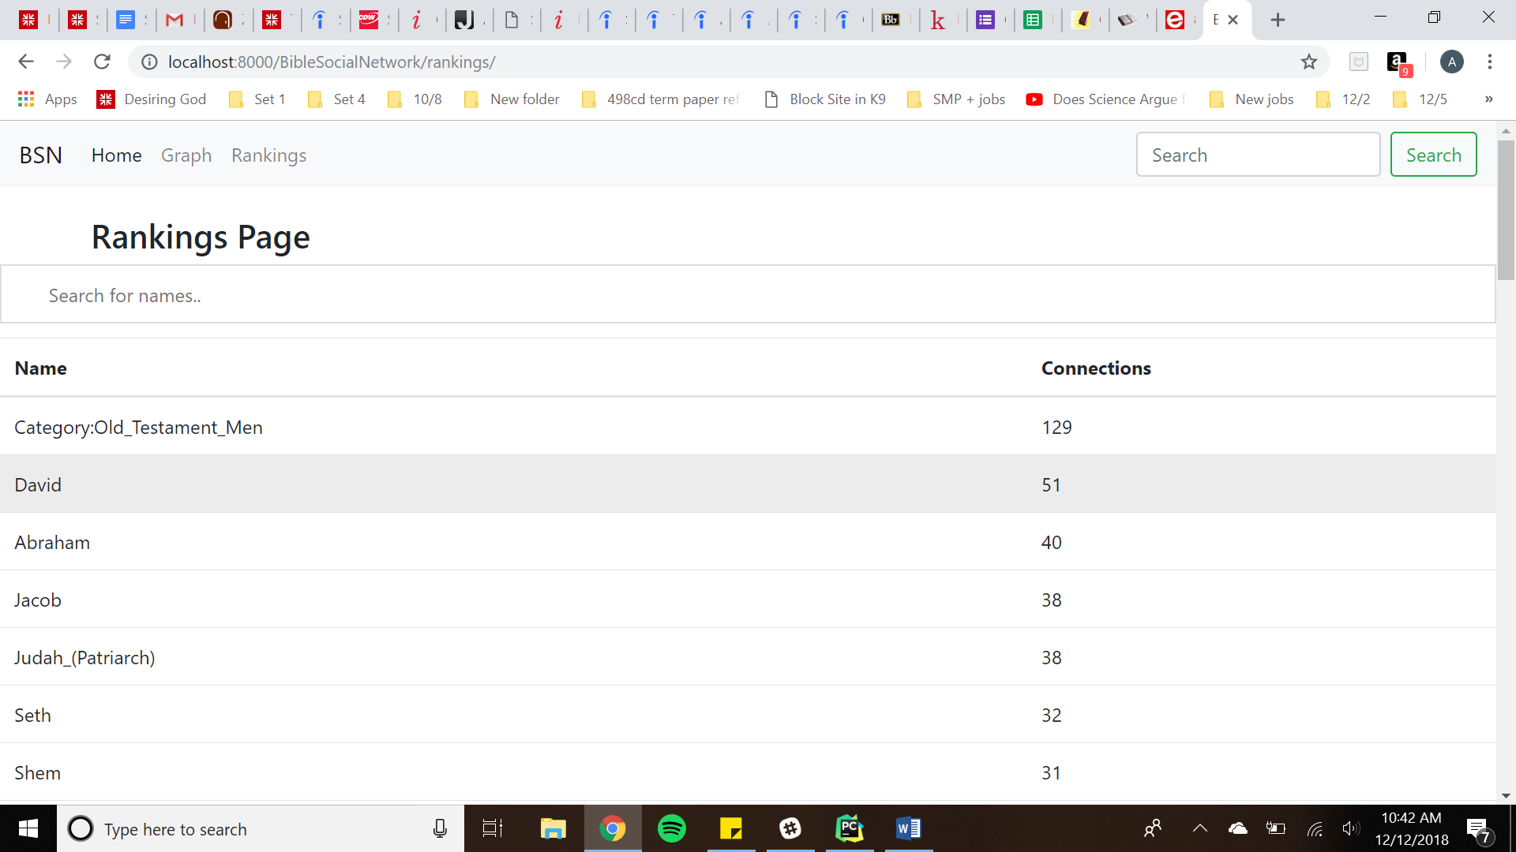

1. Check whether search functionality correctly works for Rankings table.

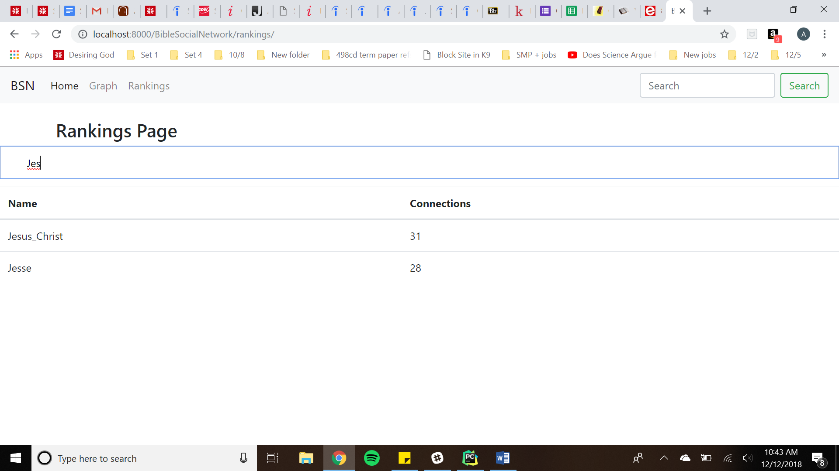

1. Check whether the “See the network visualization” button on the home page leads to the following page. **This is the old graph and is left just to show the original data.**

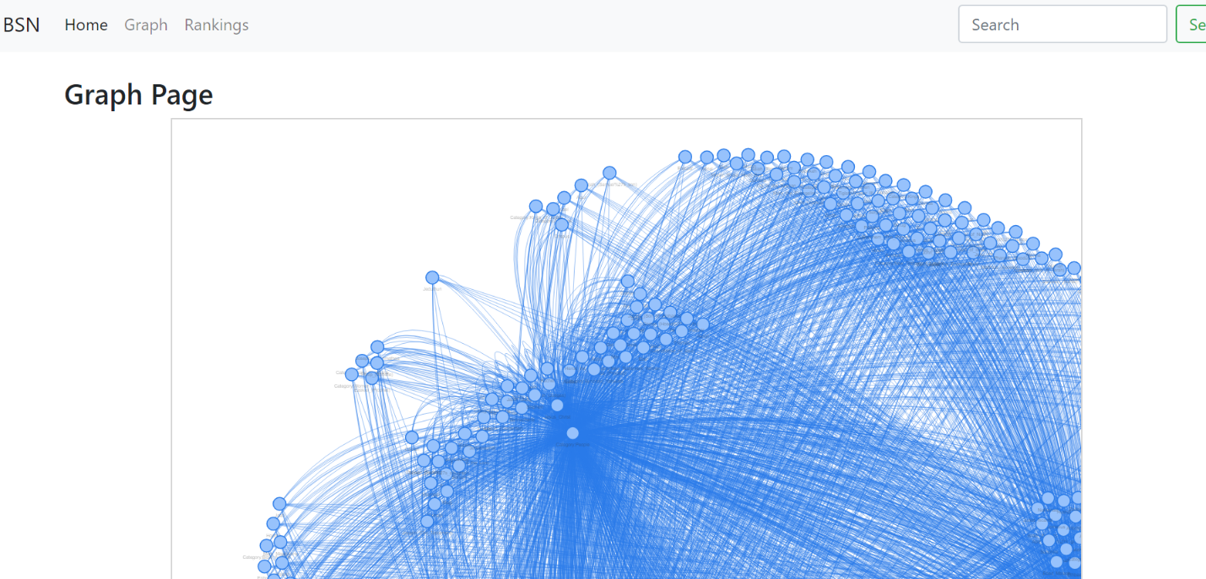

1. Check whether the edge click works – show by the thicker blue edge below.

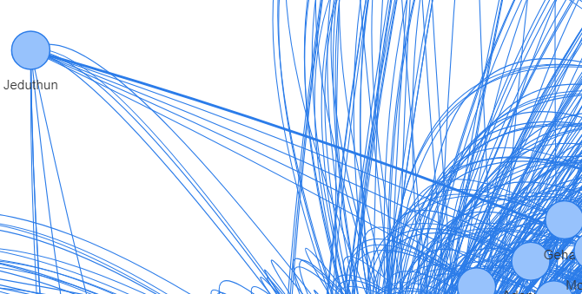

1. Check whether edge hover works.

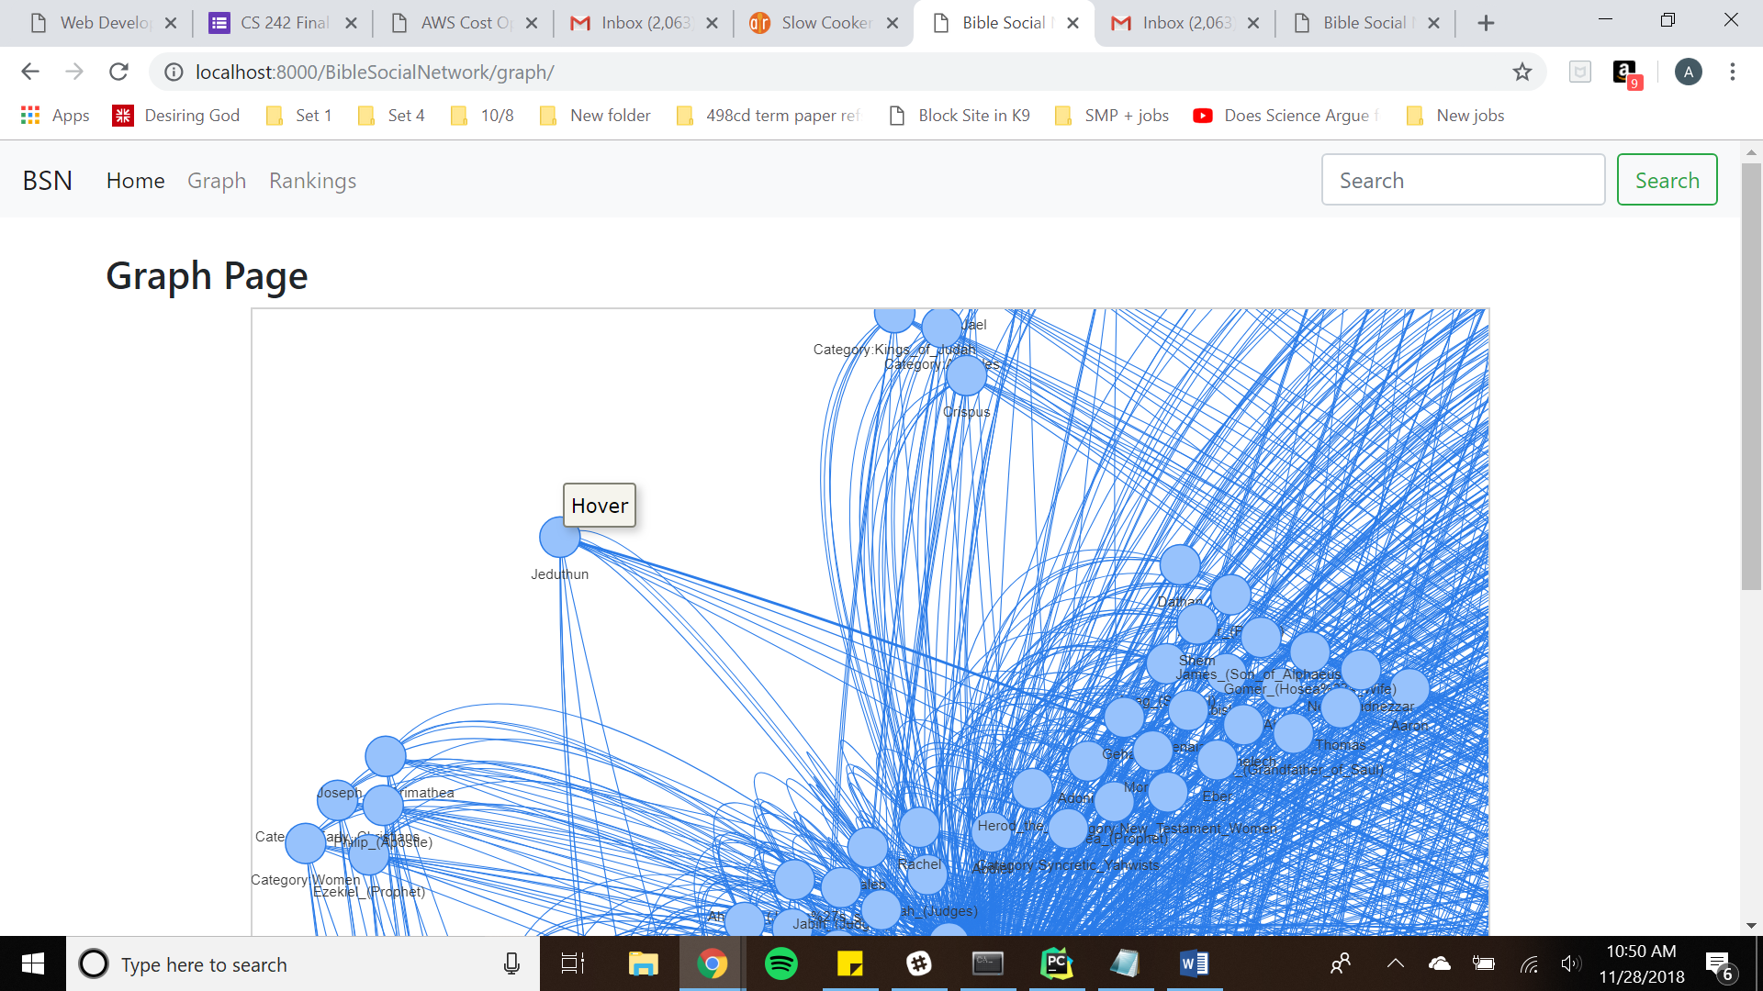

1. Check whether the navigation works and leads to the previous pages as well as the new graph page and the home page.

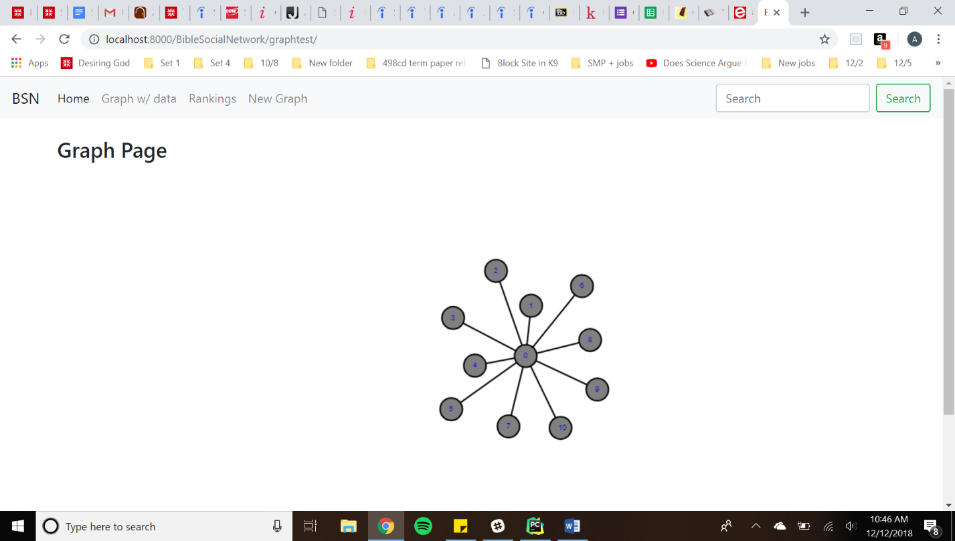

1. Check whether the New Graph page leads to the following graph. This is the design for the new graph and is not populated with the final, correct data.

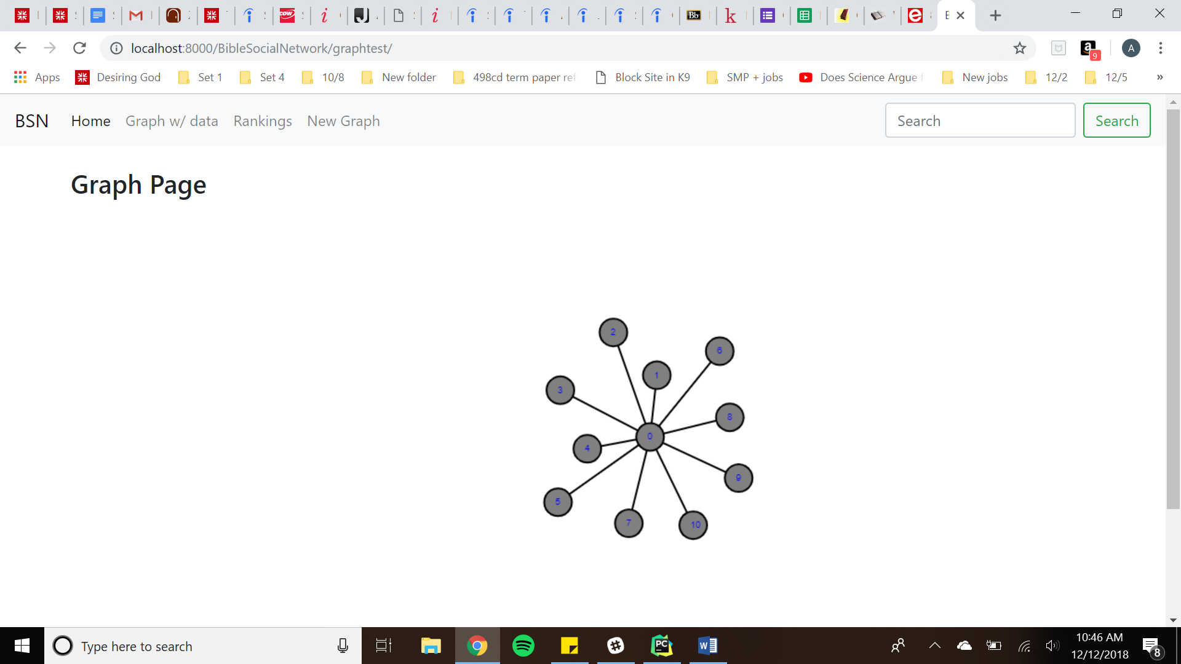

1. Check whether the edge click and node click works and if the modal pops up as below. Edge clicks must happen at the middle of the edge.

